## Additional Information

### Drive Failures RAID considerations.

<https://library.netapp.com/ecmdocs/ECMLP2502821/html/GUID-B3CF8FD0-2CDC-4AA5-9C4E-7422B8030ECF.html>

### Create A Global Hot Spare Disk

1. Select Hardware view. Under **Show drives that are** section. Select the volume group or disk pool you would like to see attached drives to.

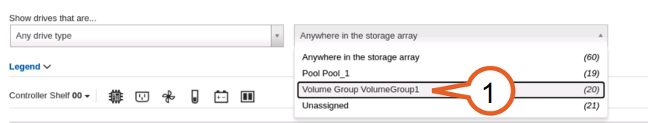

This will give us an idea which drives are within a volume group or a disk pool.

1. Right Click any of the highlighted drives and select **View settings** to make sure you use same drive settings on the hot spare (Media type, Capacity, Interface)
2. Click on Clear to start a new drive **Filter** and select the disk type/capacity.
3. Right click on any unassigned drive highlighted in **Gray** and select **Assign Hot Spare**
4. Review and click **YES. Hot Spare disk** is **Pink highlighted**.

### Drawer Loss Protection

Drawer loss protection guarantees accessibility to the data on the volumes in a pool or volume group if a total loss of communication occurs with a single drawer.

A 60-drive tray can achieve drawer loss protection when the disk pool contains 15, 20, 25, 30, 35, 40, 45, 50, 55, or 60 drives.

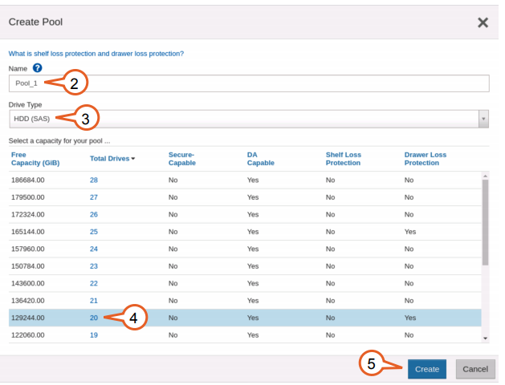

Volume reconstruction is expected when replacing drawer online.

### Documentation For Replacing Controllers/ESM/Ioms

See documentation for replacing controllers or ESMs / IOMs for instructions on unseating and reseating cables.

NetApp® E-Series Storage Systems: Replacing an Environmental Services Module Canister in a DE1600 Drive Tray or a DE5600 Drive Tray

NetApp® E-Series Storage Systems: Replacing an ESM Canister in the DE6600 Drive Tray

E-Series Replacing an IOM

Note: Be sure not to unseat or disconnect components on the working side. Doing so will result in a complete loss of access to that tray and any tray below it in the chain.

Investigate the backend cabling to ensure that all cables are securely connected and the ports display link lights.

See documentation for backend cabling.

E-Series Cabling E-Series Hardware

Drive drawer cables can be unseated and reseated if needed. These cables are powered at both ends so exercise caution when unseating and reseating these cables. Do not leave either end dangling free.

See documentation for replacing drive drawers for instructions on unseating and reseating cables.

E-Series Replacing a Drive Drawer in a 60-Drive Tray

E-Series Replacing a drive drawer in E5760 and E2860 shelves

### Write-Back Caching Forcibly Disabled

<https://kb.netapp.com/Advice_and_Troubleshooting/Data_Storage_Systems/E-Series_Storage_Array/E-Series%3A_Write_back_caching_forcibly_disabled_alert>

<https://kb.netapp.com/Advice_and_Troubleshooting/Data_Storage_Systems/E-Series_Storage_Array/Write-back_caching_forcibly_disabled_due_to_low_battery_capacity>

## How to Access E-Series Shell